Rubric for Discussion Replies
The purpose of the discussions to to interact with other students and your professor. Your discussion reply should show that you have read another student’s post, thought about it, and posted a meaningful reply. Remember to keep your replies positive and supportive.
Here are examples of replies that are minimal and do not earn any credit.
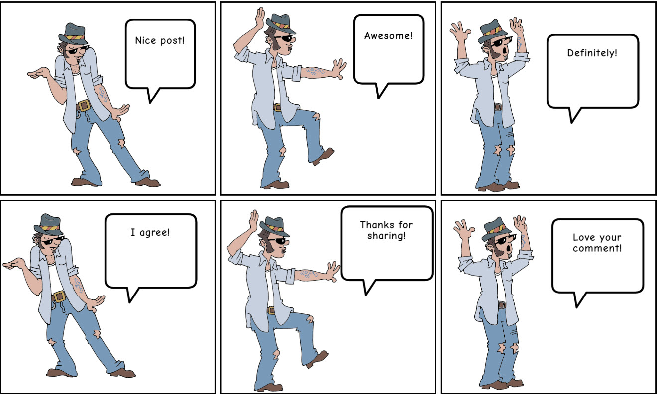
From www.MakeBeliefsComix.com

Here are some examples of replies that earn full credit.
I hope you achieve your goals and dreams you set for yourself in life. The biggest take on chapter one for me is "you can make success a habit" and never realizing that before opened my eyes. If you can make success a habit, you can succeed in anything and I can see you're already setting small habits to better succeed in life. It's interesting to read other people’s stories and struggles they've come across as we can all understand we're not alone in our life obstacles. Keep up the good work and great job!
I really appreciate what you have to say about the excuses we make for not doing something or for avoiding the work necessary to improve areas of our lives. I also think that sometimes people are so afraid to try something because they won't be perfect, and that fear of perfection prevents any movement at all. Indeed, success takes a LONG time and a lot of effort and probably several missteps and failures along the way.
I really enjoyed reading the different ways you find helpful in motivating yourself. The idea of the amount of money one could make with a degree compared to those who just have a high school diploma is a huge motivational tool. Also, I don't want to have any financial struggles in the future. Great post!
I understand what you mean by the first step being the hardest. It kind of reminds me of the idea that the hardest part of getting to the gym is actually getting there! Once your there, everything else is easy! Just like in school and getting work done. Great post!
I really like when said " For me, happiness is living peacefully with good health". Life without these two key terms it can be really harsh on us, even though you have ton of money, it can’t buy health or peace.
I completely agree with you. It’s important to not overthink the past and things we might regret, but I also think that it’s important to acknowledge it in order to see how far we’ve come and how much we’ve grown as a person. Understand that your past does not define you, as you’re growing and evolving each day.
Totally agree with you that happiness comes from being grateful and content for everything you have. We all want o achieve gig things in life, but in order to accomplish big things you have to be humble, grateful, and content for the house, family, and food you have now.
I agree that happiness is a day to day journey, and not necessarily just a destination one gets to stay at. Happiness is a feeling that is difficult to maintain but can be appreciated at the moment. Really being grateful for the good things in life and pursuing passions are actual genuine ways to savor happiness. Positive thinking can help anyone be reminded of what they have instead of what they don’t.
I agree with your response and like how you pointed out that happiness is created. I also believe your attitude and an open mind is very important to create positive situations. You did a great job with the examples you gave. Thanks for sharing.

